

**LIST OF EXPERIMENTS**

|  |  |  |  |  |  |  |  |
| --- | --- | --- | --- | --- | --- | --- | --- |
| **SR. NO.** | **EXPERIMENT NAME** | **Mapping CO** | **Mapping**  **PO** | **Page No.** | **Date** | **Remark** | **Signature** |
| 1 | Verification of Kirchhoff’s Laws (KCL and KVL) | 1 | 1,2,4,9,12 |  |  |  |  |
| 2 | Verification of Superposition Theorem | 1 | 1,2,4,9,12 |  |  |  |  |
| 3 | Verification of Thevenin’s theorem | 1 | 1,2,4,9,12 |  |  |  |  |
| 4 | Verification of Maximum Power Transfer theorem | 1 | 1,2,4,9,12 |  |  |  |  |
| 5 | R-L Series circuit | 2 | 1,2,4,9,12 |  |  |  |  |
| 6 | Measurement of 3-Φ Power by two wattmeter method | 3 | 1,2,4,9,12 |  |  |  |  |
| 7 | Efficiency and Regulation of 1-Φ Transformer | 4 | 1,2,4,9,12 |  |  |  |  |
| 8 | Study of DC machines | 5 | 1,12 |  |  |  |  |

**Subject: Basic Electrical Engineering**

**Experiment No.**

**Name of Experiment:**

**Date of Performance:**

**Date of Submission:**

**Grade/Marks:**

**Rubrics for Internal Evaluation:**

|  |  |  |
| --- | --- | --- |
| **Sr. No.** | **Rubrics** | **Weightage** |
| 1 | Punctuality (2) |  |
| 2 | Performance (4) |  |
| 3 | Question/Answers (2) |  |
| 4 | Journal Writing (2) |  |
| **Total** | |  |

**Practical Incharge**

**CIRCUIT DIAGRAM:**

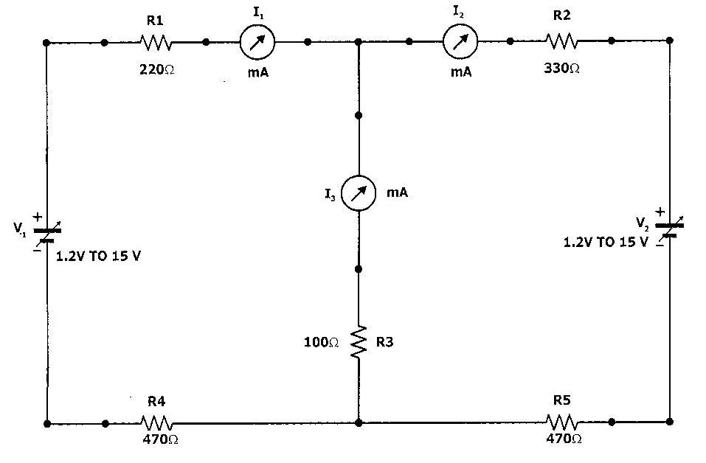

V1= ______ Volts V2 = ______ Volts

**OBSERVATION TABLE :**

|  |  |  |
| --- | --- | --- |
| **V1 Active** | **V2 Active** | **V1 & V2 Active** |
| I1 ‘ = | I1 ‘’ = | I1  = |
| I2‘ = | I2 ‘‘= | I2 = |
| I3‘ = | I3 ‘’ = | I3 = |

**EXPERIMENT NUMBER 2**

DATE:

**NAME:**

**SUPERPOSITION THEOREM**

**AIM :**

Verification of Superposition theorem

**EQUIPMENTS / COMPONENTS:** Trainer kit, patch cords, multi-meter

**THEORY** **: -**

**SUPERPOSITION THEOREM:**

*In a linear network containing more than one active source (i.e. the voltage source and constant current source), the resultant current in any element is algebraic sum of the currents that would be produced by each source acting alone, all the other sources being represented by their respective internal resistances.*

In simple words, the superposition principle states that *the voltage across (or current through) an element in a linear circuit is the algebraic sum of the voltages across (or currents through) that element due to each independent source acting alone*.

The constant voltage sources are represented by their internal resistance if given or simply zero resistance i.e. short circuits if internal resistances are not mentioned.

The constant current sources are represented by infinite resistance i.e. open circuits.

**CALCULATIONS**

**THEORETICAL VERIFICATION**

**PROCEDURE:**

1. Connect the trainer kit to mains supply & switch it ON
2. Make V1 supply to 5 Volts & V2 supply to 10 Volts, by connecting voltmeter across it.
3. Connect both supply to the network (as shown in Fig. 1) & measure the current

one by one using ammeter & short circuit other two

1. Measure the current flowing through all three branches I1, I2, I3
2. Now short circuit the V2 supply & Connect V1 only (as shown in Fig. 2) & measure current flowing through all three branches I1’, I2’, I3’
3. Now short circuit the V1 supply & Connect V2 only (as shown in Fig. 3) & measure current flowing through all three branches I1’’, I2’’, I3’’
4. And verify the theorem: I1 = I1’ + I1’’

I2 = I2’ + I2’’ I3 = I3’ + I3’’

1. Repeat the experiment by changing the V1& V2 Values & also reversing the polarity of one of the voltage source

**THEORETICAL VERIFICATION (Contd.)**

|  |  |  |  |  |  |
| --- | --- | --- | --- | --- | --- |
| **V1 Active** | | **V2 Active** | | **V1 & V2 Active** | |
| Measure Value | Calculated Value | Measure Value | Calculated Value | Measure Value | Calculated Value |
| I1 ‘ = |  | I1 ‘’ = |  | I1  = |  |
| I2‘ = |  | I2 ‘‘= |  | I2 = |  |
| I3‘ = |  | I3 ‘’ = |  | I3 = |  |

**RESULTS:**

**CONCLUSION:**